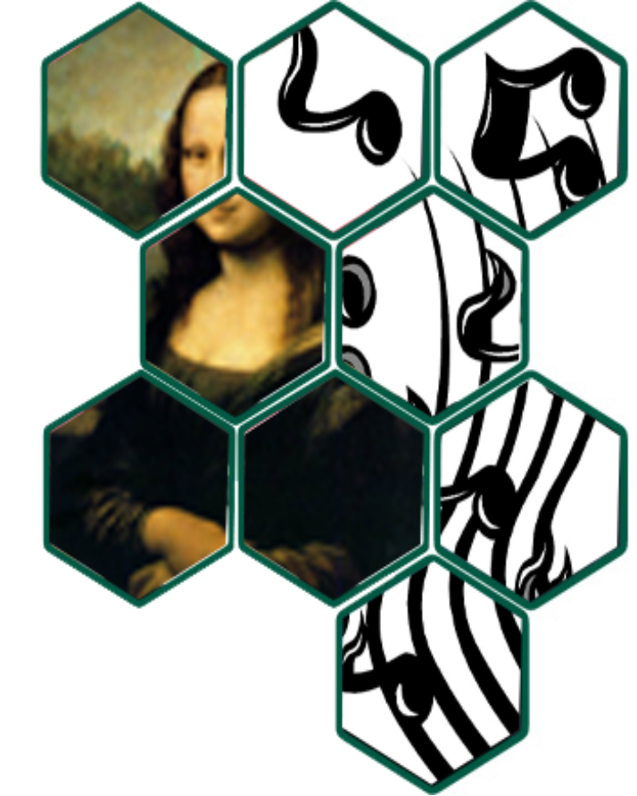 | SPSU Arts & Sciences Showcase  Week of April 17-April 23  April 17-26: 6th Annual Honors Comp II: Photo Exhibition and Sale (Student Center & J Building)  April 18-23: School of Arts and Sciences Poster Contest: Student Center  April 19: SPSU Band Concert dedicated to Prof. Jack Haley: 4:30pm Student Center Theatre -bring your dancing shoes (if you can add that statement in the flier--please do)  Light refreshments to be served after band concert  April 20: A&S Showcase: 1-4pm Student Center Ballroom

